Final Project

ITMD 411

GUI Application with DB connectivity to perform CRUD operations along with Java Data Analytics and Serialization

2013

SagarikaMuniraj

IIT, Chicago

5/10/2013

Table of Contents

Project Abstract 1

System Requirements 2

Data Model 2

Application Model 5

Architecture and Code Structure 6

Packages used: 6

Domain files 6

Connector files 6

Csvimport files 7

Driver files 7

Data 7

Project Insights with Requirements 8

Steps for Execution 8

Expected Results and Screen Captures 8

1. Home Screen 8

# 

# Project Abstract

This project is creating using the following

* Java for the Service layer
* Swing for the GUI
* MySQL Database

The project is intended to perform the following functionalities

* Read from CSV file and load data into the Database
* Demonstrate the high level CRUD operations by connecting to the Database from the Java layer
* Perform a few Data Analytics in Java – Finding Solstices and Equinoxes
* Serializing and Deserializing data

The project demonstrates easy usability and is user friendly. UI is intuitive even to a newbie user.

# System Requirements

• OS – Windows 7

• IDE – NetBeans 7.2.1

• JDK – 1.7.0

• JRE Version 6

* MySQL 5.2.47
* MYSQL Connector - mysql-connector-java-5.1.24-bin

# Data Model

|  |
| --- |
| DaylightRecord |
| sunrise |
| sunset |
| daylength |
| nightlength |

It is a simple database table that holds all the values read from the CSV file

* Sunrise - This is a timestamp that holds the date and time of the sunrise in

‘yyyy-mm-dd hh:mm:ss’ format

* Sunset - This is a timestamp that holds the date and time of the sunset in

‘yyyy-mm-dd hh:mm:ss’ format

* Daylength – This is an ‘int’ field that holds the length of day in minutes (sunset-sunrise)
* Nightlength – This is an ‘int’ field that holds the length of the night in minutes (next day’s sunrise – current day’s sunset)

# 

# Application Model

Run

Create

Home Screen

Create Screen

Update

Update Screen

Serialize

Winter Solstice

Retrieve All

Data  
Analytics

Vernal Equinox

Deserialize

Delete Screen

Delete

Retrieve Screen

Retrieve

Retrieve All Screen

Quit

Autumn Equinox

Summer Solstice

The Application model of the project is as depicted above.

The User is first presented with a home screen

Home screen consists of the following buttons:

* ReadCSV
* Create – leads to a new create screen
* Update – leads to a new update screen
* Retrieve – leads to Retrieve screen
* Retrieve All – leads to Retrieve All screen
* Delete – Leads to Delete screen
* Serialize
* Deserilaize
* Data Analytics – Leads to Data Analytics Screen
* Quit

Each of the subscreens has a provision to (‘back’ button) take back the user to the main screen.

# Architecture and Code Structure

## Packages used:

* Domain - Used for the java classes to store Record and its inherited DayLightRecord
* Driver - has the home screen and each of the subscreens
* Connector - Java code to connect to the Database
* Csvimport - Code to read from the csv file and load into the Database

### Domain files

* Record.java – abstract class to hold the base data of sunrise and sunset from csv file
* DaylightRecord.java – class extending Record with daylength and nightlength fields

### 

### Connector files

* JdbcUtilities.java – Has all the code to connect to the Database

The getConnection() is present here. Please change this to the appropriate userid and passwords.

I have used the default values (root and admin for userid and password).

### Csvimport files

* ImportUtilities.java – This has the following functions
  + - buildDayLightRecordsList() – to read from the CSV file
    - displayDayLightRecordContents() – to display the read records for developer’s testing
    - createAndLoadDatabaseTables() – to create the Database table and load it with the data read from the CSV file
    - sql_exec() – to connect to the database and execute any query
    - getlistofnames() – to get all the days of the year. The user can choose a date from this to update or retrieve

### Driver files

* crud.java:

This is the home screen from which any functionality can be selected

* DataAnalytics.java:

Performs data analytic functions to find out Winter Solstice, Vernal Equinox, Summer Solstice and Autumnal Equinox

* Record Creation.java:

Takes user inputs for sunrise and sunset and inserts them as a new row into the database

* RecordUpdate.java:

User can select a column to update and give a value to update

* RecordRetrieve.java:

User selects a particular record to view its details

* RecordRetrieveAll.java:

User clicks to retrieve all data

* RecordDelete.java:

User selects a particular record to delete

### Data

This folder is placed outside the src and contains:

* DayLightRecord.ser – This is used to serialize and deserialize
* sunrise-sunset.csv - This is the input file from which the data is read

# Project Insights with Requirements

* Ability to read from CSV file and load it into the database table
* The data can be reinitialized at any point of execution of the project which would delete the current data and reset it to the data from CSV
* GUI components are provided for each of the CRUD functionalities
* User can get back to the home screen from any of these CRUD screens
* GUI components are provided for Serializing and Deserializing
* GUI component is provided for Data Analytics that calculates the solstices and equinoxes

# Steps for Execution

* Open the project in NetBeans IDE
* Build and run
* Check the **Database connection string in connector.JdbcUtilities.java**

**getConnection()** method has the default credentials. Please change these if required

* A HomeScreen is presented from which any of the SubScreens can be chosen
* User can get back to the HomeScreen from any of the SubScreens

# Expected Results and Screen Captures

### Home Screen

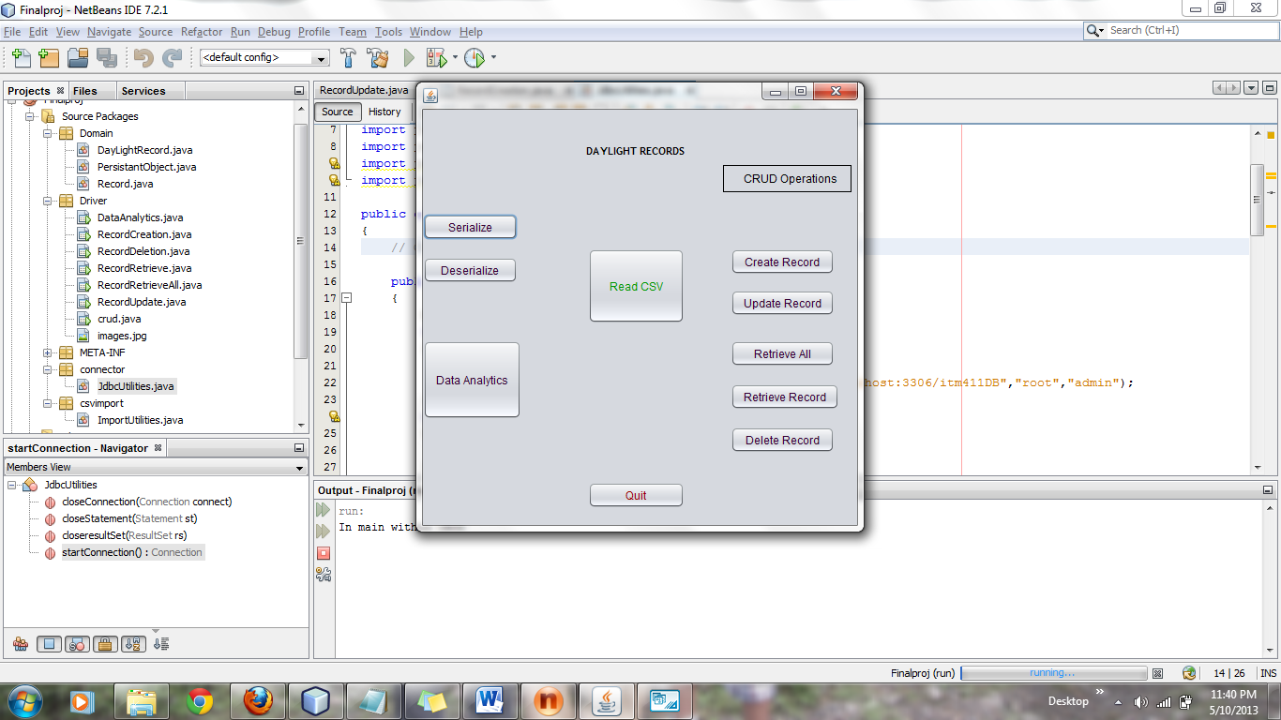

1. Read CSV

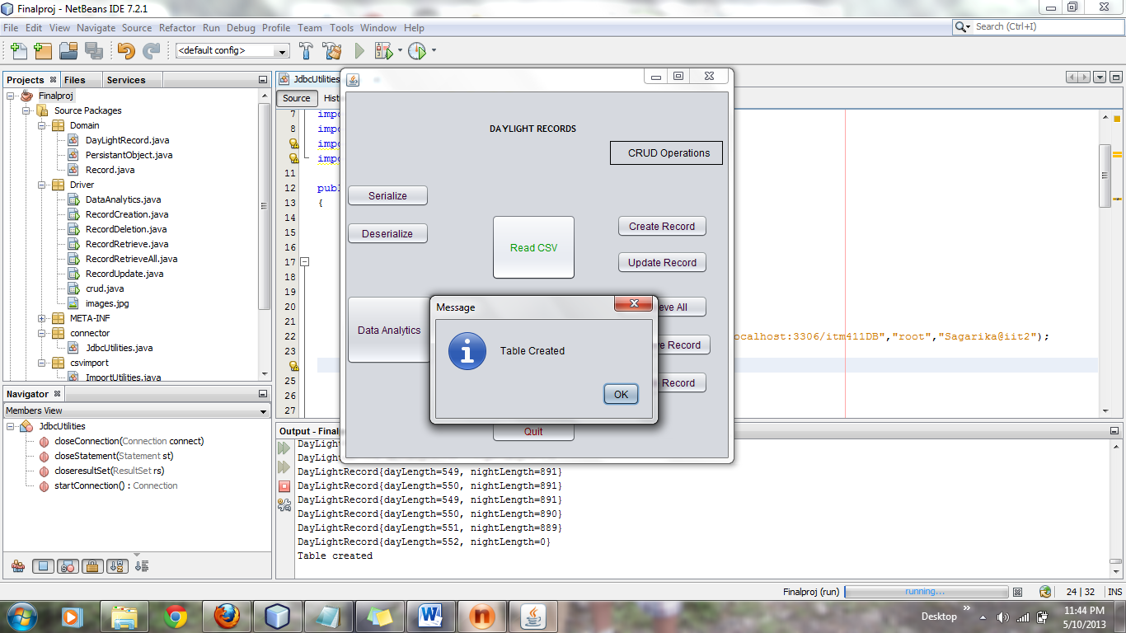

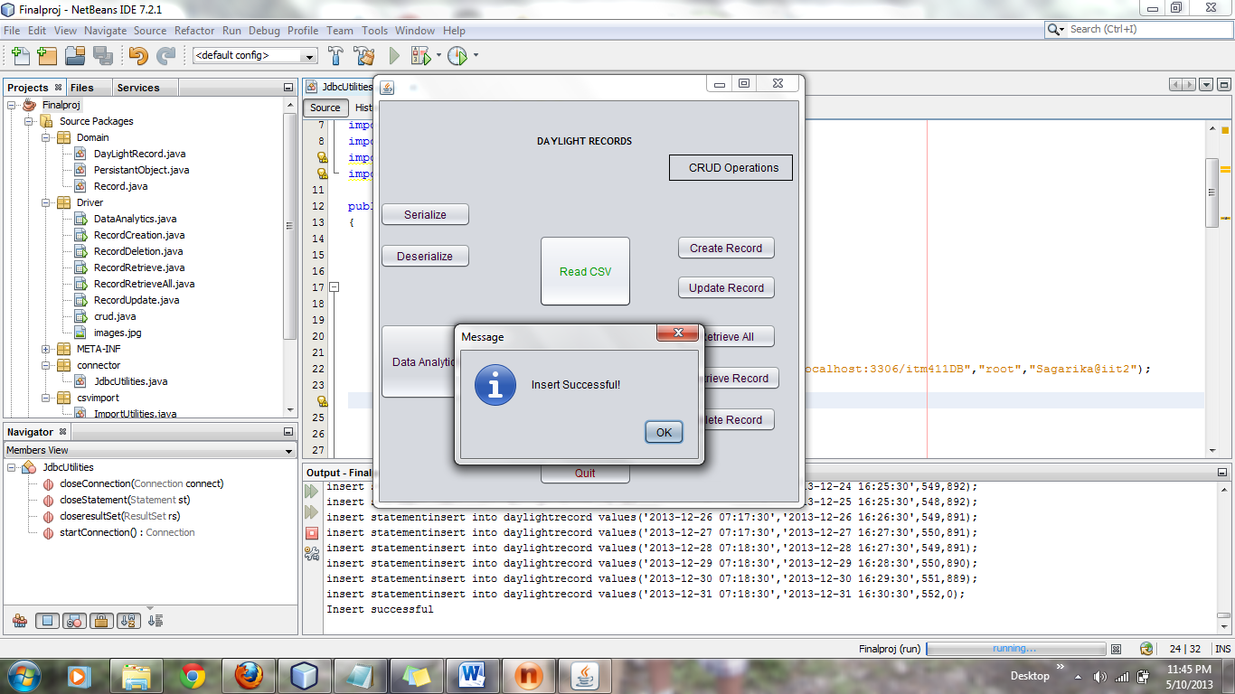

1. Serialize



1. Deserialize

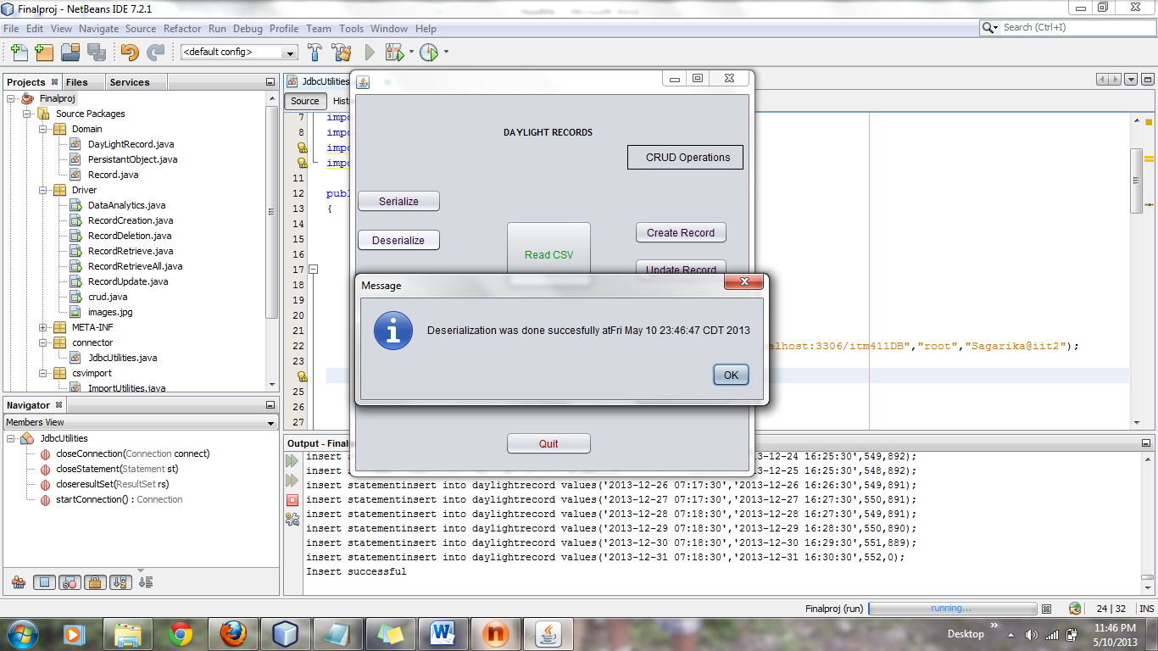

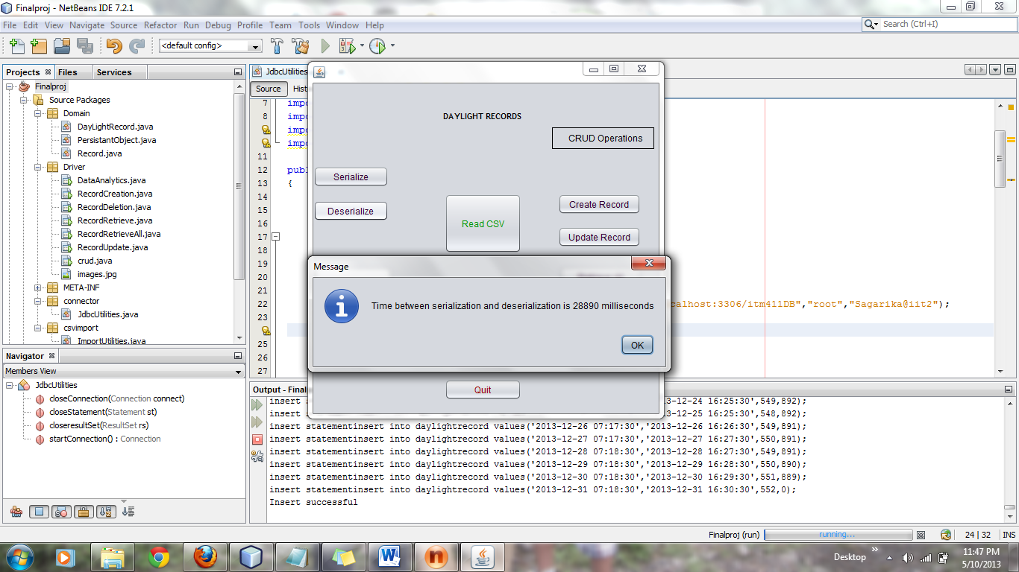

1. Data Analytics

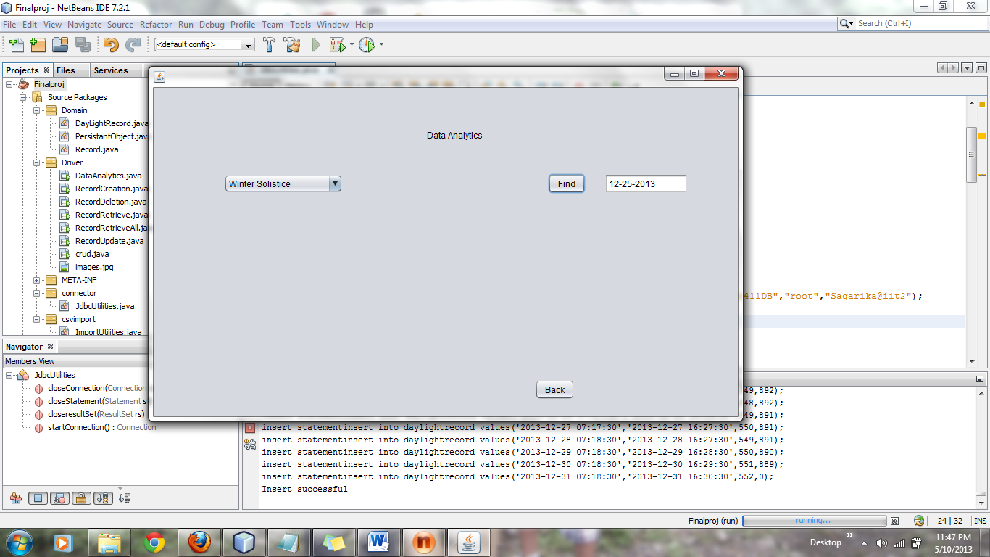

1. Create Record

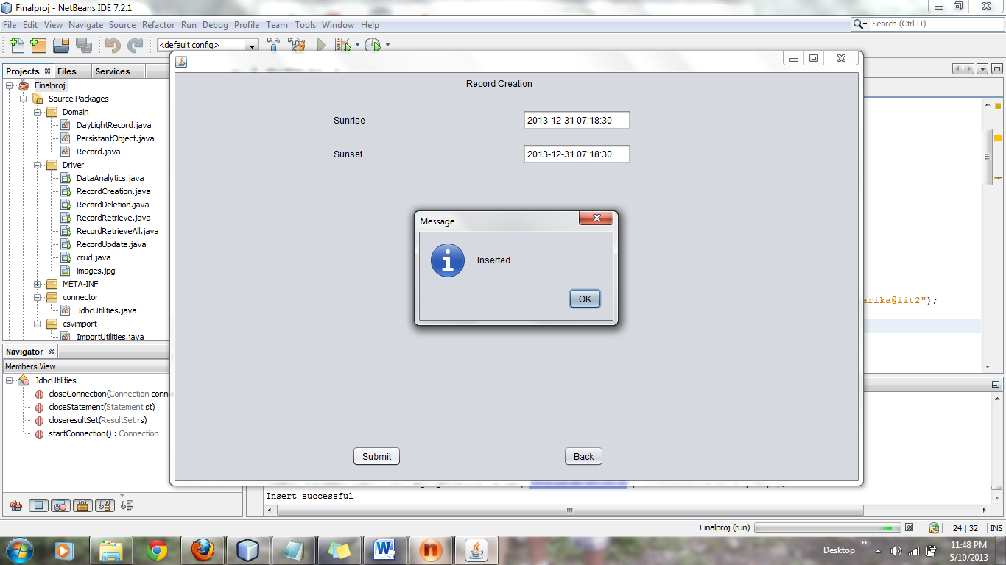

1. Retrieve

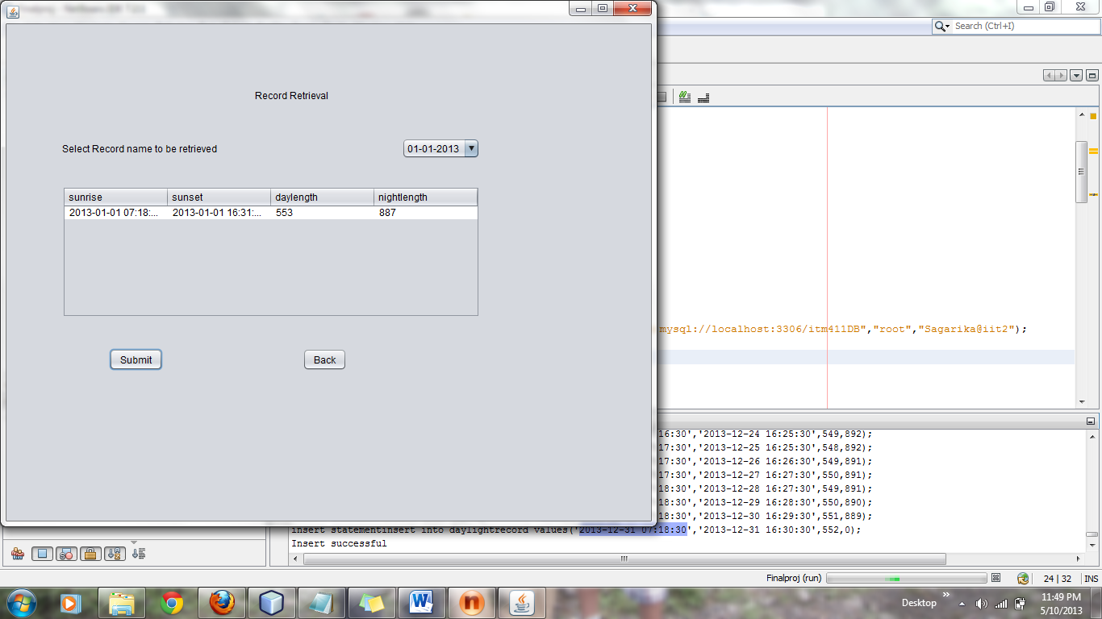

1. Retrieve All

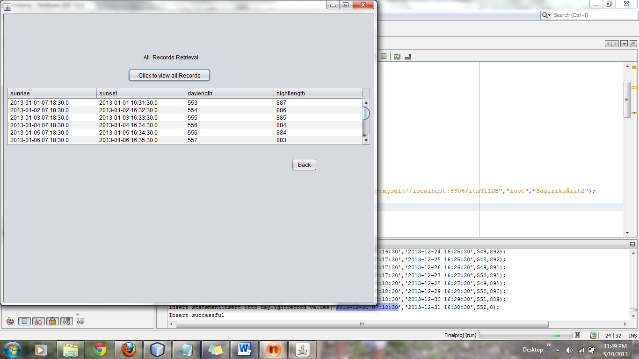

1. Update

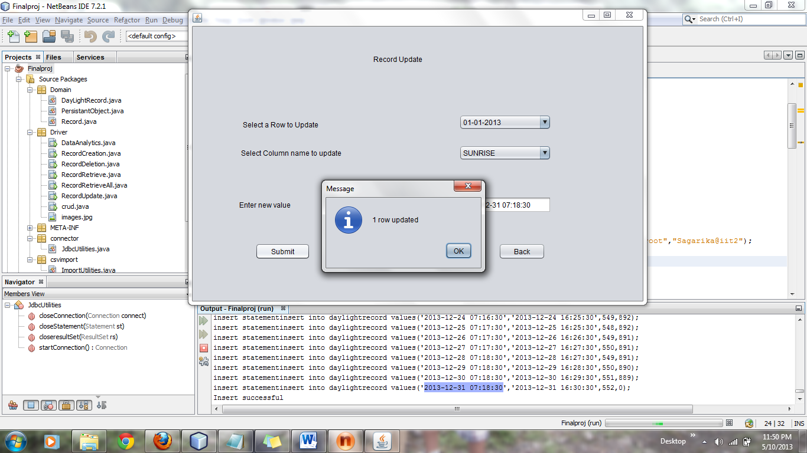

1. Delete

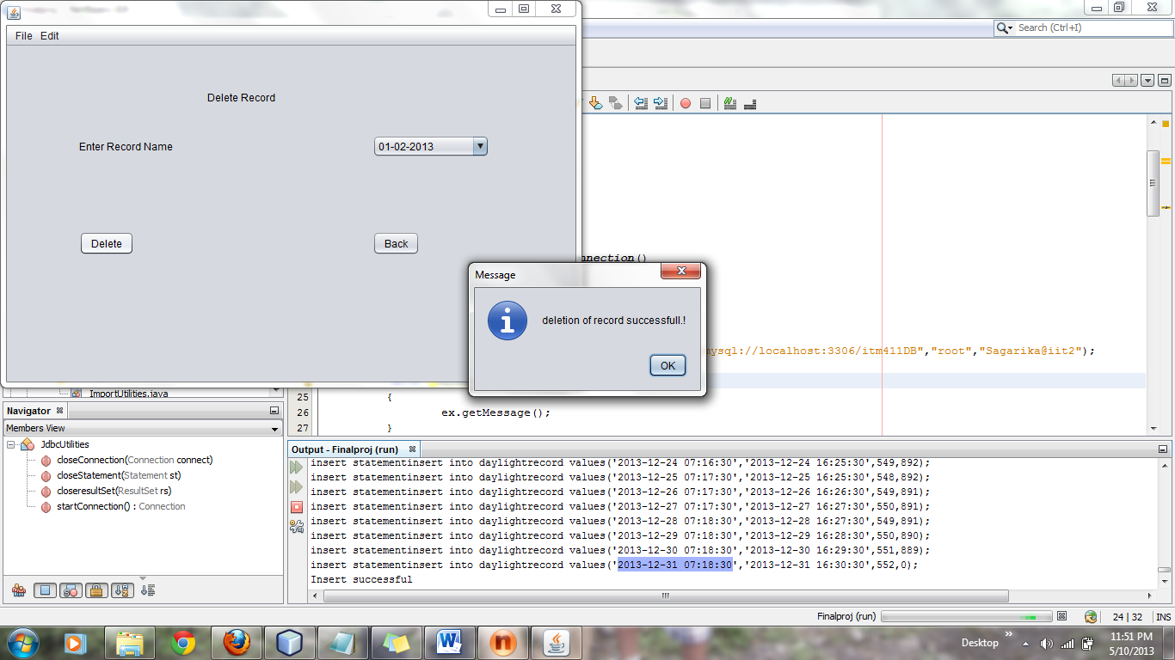

1. Exit

